Introduction to SQL

Lab - 1. Create a new database named school_db and a table called students with the following columns: student_id, student_name, age, class, and address.
ANS.
- CREATE DATABASE school_db

- CREATE TABLE student (student_id int PRIMARY KEY AUTO_INCREMENT,student_name varchar(50) , age int , class varchar (50),address varchar (100))
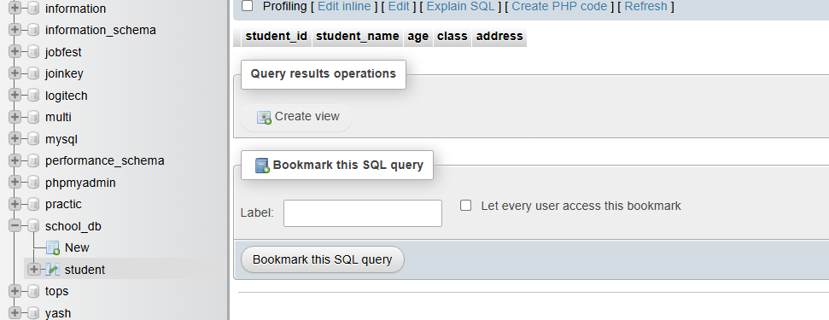

Lab - 2 -> Insert five records into the students table and retrieve all records using the SELECT statement.
ans.
- INSERT INTO student VALUES (1,'yash',22,'python','rajkot'),(2,'mohit',20,'C++','rajkot'),(3,'rudra',22,'php','rajkot'),(4,'abc',18,'java','rajkot'),(5,'xyz',20,'html','rajkot')

- SELECT *FROM student
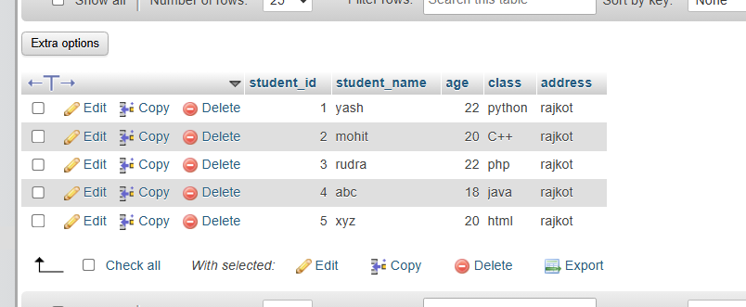

2. SQL Syntax
Lab – 1 Write SQL queries to retrieve specific columns (student_name and age) from the
students table.
Ans.
- SELECT student_name,age FROM student
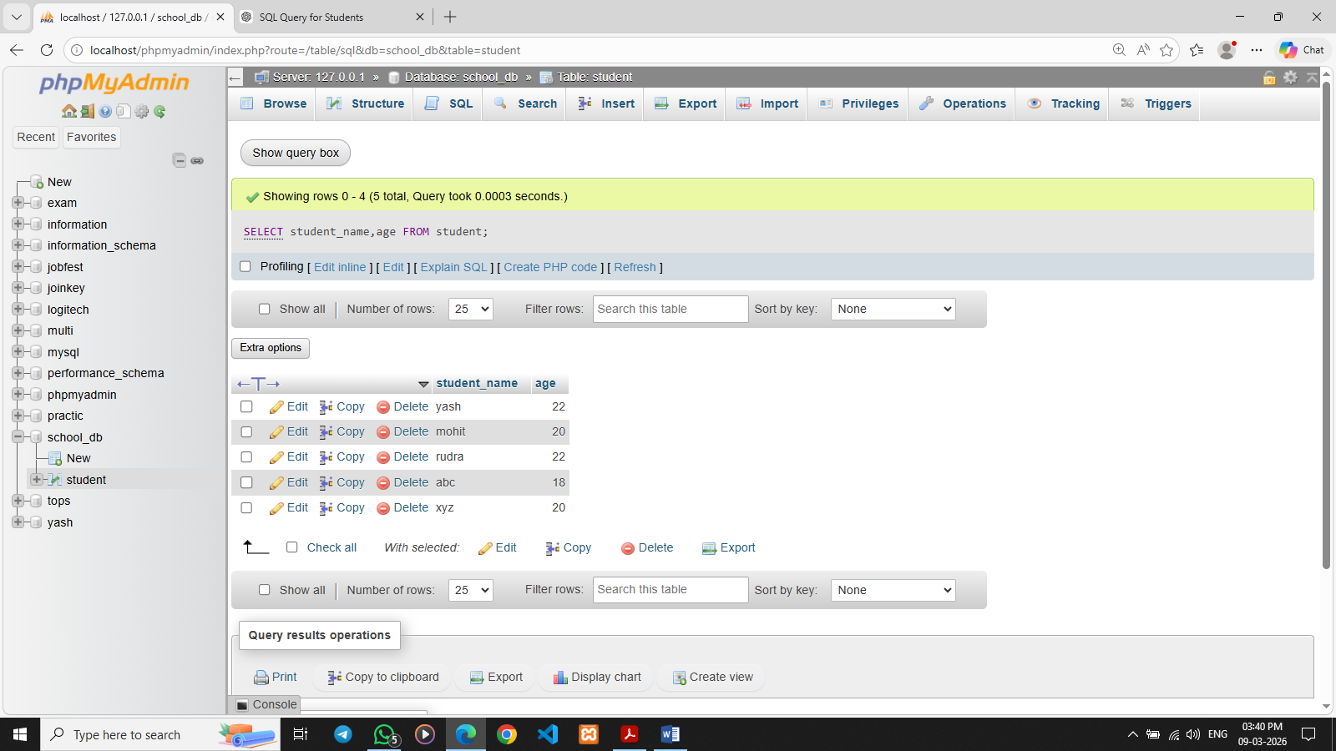
Lab – 2 Write SQL queries to retrieve all students whose age is greater than 10.
Ans.
- SELECT * from student WHERE age > 10
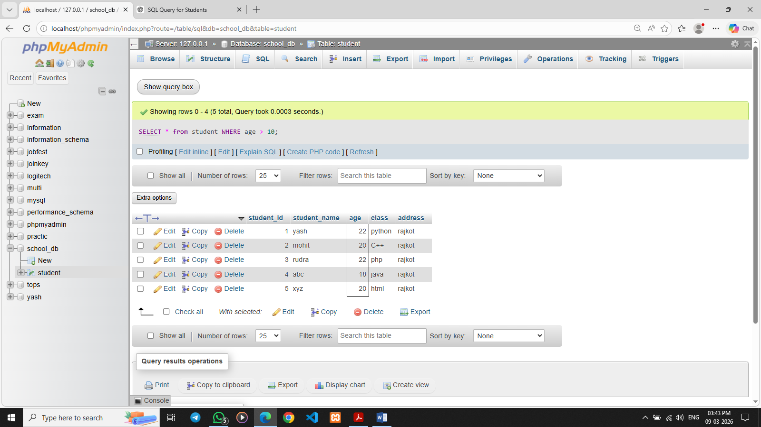

3. SQL Constraints
Lab – 1 Create a table teachers with the following columns: teacher_id (Primary Key), teacher_name (NOT NULL), subject (NOT NULL), and email (UNIQUE).
Ans.
- CREATE TABLE teachers (
teacher_id int PRIMARY key AUTO_INCREMENT,
teacher_name varchar(50) not null,
subject varchar (50) NOT null,
email varchar(50) UNIQUE);
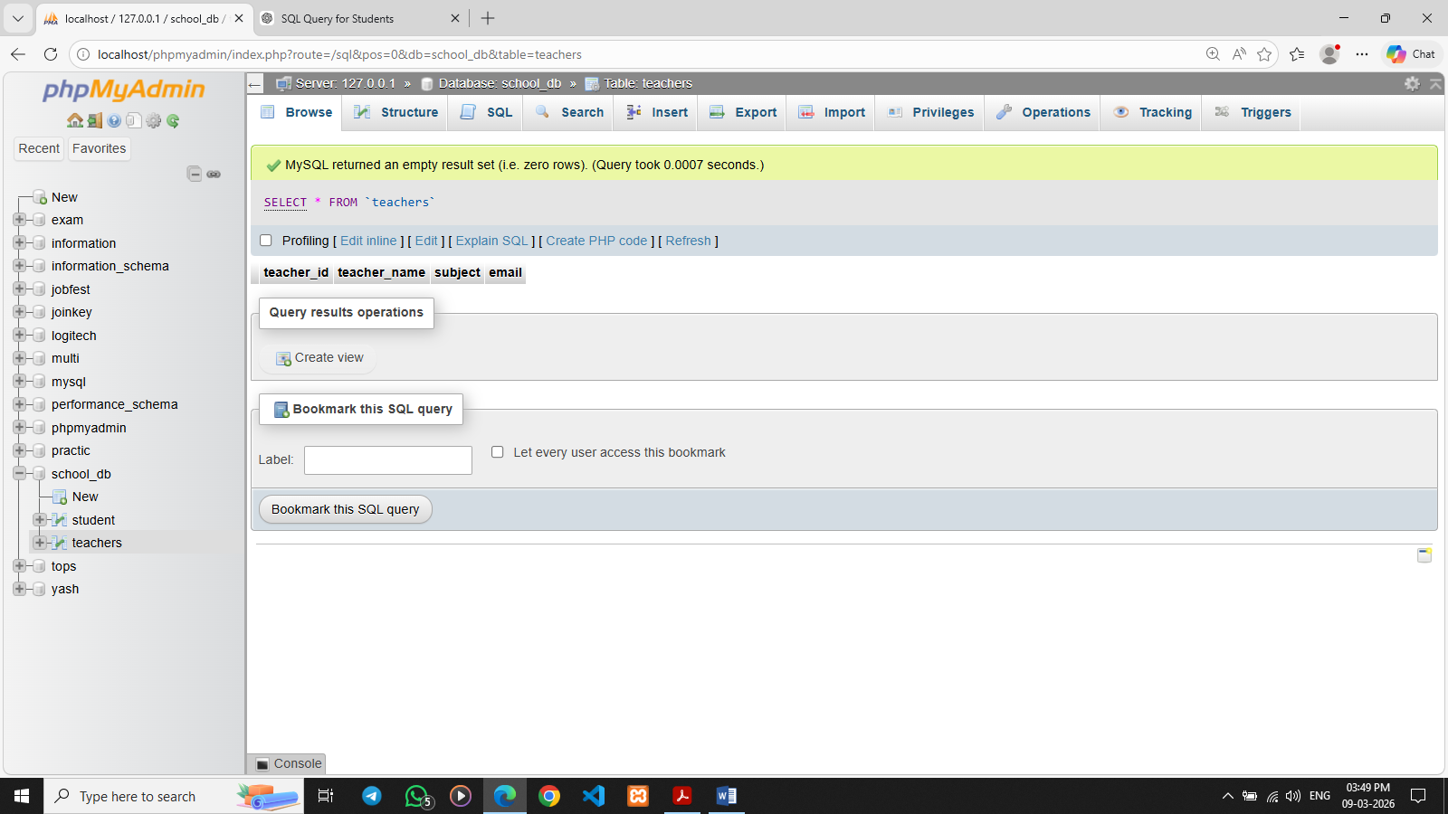

Lab – 2 Implement a FOREIGN KEY constraint to relate the teacher_id from the
teachers table with the students table.
Ans.

